Unit 1: Introduction
1) Compiler Vs Interpreter:
Compiler | Interpreter
It takes entire program as input and converts into machine code. | At a time, it takes one line of program as input and converts into machine code.
It usually generates intermediate code in the form of the object file (.obj). | It doesn't create an intermediate object code.
The compilation is done before execution. | Compilation and execution take place simultaneously.
Faster execution of control statements as compared to the interpreter. | Slower execution of control statements as compared to the compiler.
Memory requirement is more due to the creation of object code. | It requires less memory as it does not create intermediate object code.
Detected errors in the program get displayed after the entire program is read by compiler. | Detected errors in the program get displayed after each instruction read by the interpreter.
Example: C, C++, Java | Example. BASIC, Python, PHP, JavaScript

2) Procedural programming vs Object oriented programming approach:

PROCEDURAL PROGRAMMING | OBJECT ORIENTED PROGRAMMING
In procedural programming, program is divided into small parts called functions/procedures/routines. | Object-oriented programming is based on concept of objects which contains data (variable) and code (method).
Procedural programming follows top down approach. This approach begins with high level design and ends with low level design or development. | Object oriented programming follows bottom up approach. This approach begins with low level design or development and ends with high level design.
First Main() function is written and all sub functions are called from main function. Then, sub functions are defined based on the requirement. | First code is developed for sub-tasks in the form of modules and then modules are integrated with main() function to complete whole task.
There is no access specifier in procedural programming. | Object oriented programming have access specifiers like private, public, protected etc.
Adding new data and function is not easy. | Adding new data and function is easy.
Procedural programming does not have any proper way for hiding data so it is less secure. | Object oriented programming provides data hiding so it is more secure.
In procedural programming, overloading is not possible. | Overloading is possible in object-oriented programming.
In procedural programming, function is more important than data. | In object-oriented programming, data is more important than function.
Procedural programming is based on unreal world. | Object oriented programming is based on real world.
Examples: C, FORTRAN, Pascal, Basic etc. | Examples: C++, Java, Python, C# etc.

Now-a-days, both approaches are combined together and followed in modern software design.

3) Dynamic vs Static type:

Statically typed languages:
- A language is statically-typed if the type of a variable is known at compile-time.
- Common examples of statically-typed languages include Java, C, C++, FORTRAN, Pascal and Scala.
- In Statically typed languages, once a variable has been declared with a type, it cannot ever be assigned to some other variable of different type and doing so will raise a type error at compile-time (some IDE’s generally shows a Red Cross mark denoting the error).
- Statically-typed languages require you to declare the data types of your variables before you use them.

Example: example in java
int data;
data = 50;
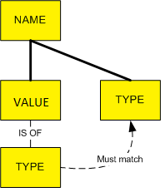
data = “Hello World!”; // This is illegal & causes a compilation error

Dynamically typed languages:
- A language is dynamically-typed if the type of a variable is checked during run-time.
- Common examples of dynamically-typed languages include JavaScript, Objective-C, PHP, Python, Ruby, Lisp, and Tcl.
- In Dynamically typed languages, variables are bound to values at run-time by means of assignment statements, and it is possible to bind the same variables to values of different types during the execution of the program.
- Dynamically-typed languages do not require you to declare the data types of your variables before you use them.
Example: example in python
data = 10;
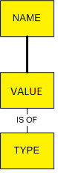
data = “Hello World!”; # No error

4) Strongly vs weekly type:
Strongly typed languages: Conversion between uncorrelated data types is not done implicitly.
Corelated data types are int, float, byte, decimal and uncorrelated data types are for example int and string. C, C++, Java and python are strongly typed languages.
Example: in python
A = 6 + “hello” # this is an error.

Weakly typed languages: Conversion between uncorrelated data types is done implicitly.
Javascript, Perl and PHP are weakly typed languages.
Example: in PHP
$temp = “hello” + 10; // No error.

5) Comparing Programming Languages: C, C++, JAVA, C#:
To compare different programming languages, we will understand execution process of each language.

- Execution process in C & C++:
Execution of a C/C++ program involves four stages using different compiling/execution tool, these tools are set of programs which help to complete the C/C++ program's execution process.
1) Preprocessor
2) Compiler
3) Linker
4) Loader

1) Preprocessor
This is the first stage of any C/C++ program execution process; in this stage Preprocessor processes the program before compilation. Preprocessor include header files, expand the Macros.

2) Complier
This is the second stage of any C/C++ program execution process, in this stage generated output file after preprocessing (with source code) will be passed to the compiler for compilation. Complier will compile the program, checks the errors and generates the object file (this object file contains assembly code).

3) Linker
This is the third stage of any C/C++ program execution process, in this stage Linker links the more than one object files or libraries and generates the executable file.

4) Loader
This is the fourth or final stage of any C/C++ program execution process, in this stage Loader loads the executable file into the main/primary memory. And program run.

Different files during the process of execution
Suppose, you save a C program with prg1.c – here .c is the extension of C code, prg1.c file contains the program (source code of a C program). Preprocessor reads the file and generates the prg1.i (prg1.ii – for c++ source code) file, this file contains the preprocessed code.
Compiler reads the prg1.i file and further converts into assembly code and generates prg1.s and then finally generates object code in prg1.o file.
Linker reads prg1.o file and links the other assembly/object code or library files and generates executable file named prg1.exe.
Loader loads the prg1.exe file into the main/primary memory and finally program run.
One more file is created that contains the source code named prg1.bak; it’s a backup file of the program files.
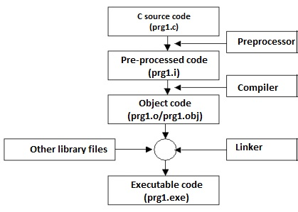

- Execution process in Java:
In java, the name you give to a source file is very important. For example, the name of the source file can be simple.java. If your program has compilation errors, you have to modify the program to fix them, then recompile it. If your program has runtime errors or does not produce the correct result, you have to modify the program, recompile it, and execute it again.

The Java language is a high-level language, but Java bytecode is a low-level language. The bytecode is similar to machine instructions but is architecture neutral and can run on any platform that has a Java Virtual Machine (JVM). Rather than a physical machine, the virtual machine is a program that interprets Java bytecode. This is one of Java’s primary advantages: Java bytecode can run on a variety of hardware platforms and operating systems. Java source code is compiled into Java bytecode and Java bytecode is interpreted by the JVM. Your Java code may use the code in the Java library. The JVM executes your code along with the code in the library.
To execute a Java program is to run the program’s bytecode. You can execute the bytecode on any platform with a JVM, which is an interpreter. It translates the individual instructions in the bytecode into the target machine language code one at a time rather than the whole program as a single unit. Each step is executed immediately after it is translated.
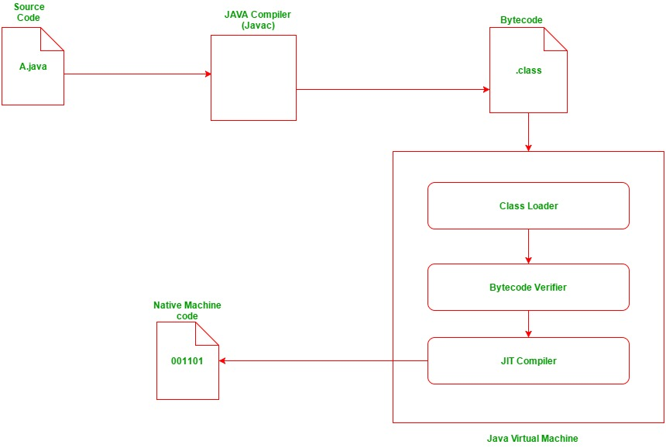

- Execution process in C#:
The Code Execution Process involves the following two stages:

1) Compiler time process
2) Runtime process

1. Compiler time process-
The .Net framework has one or more language compliers, such as Visual Basic, C#, Visual C++, JScript, or one of many third-party compilers such as an Eiffel, Perl, or COBOL compiler.
Any one of the compilers translate your source code into Microsoft Intermediate Language (MSIL) code.
For example, if you are using the C# programming language to develop an application, when you compile the application, the C# language compiler will convert your source code into Microsoft Intermediate Language (MSIL) code.
In short, VB.NET, C# and other language compilers generate MSIL code. (In other words, compiling translates your source code into MSIL and generates the required metadata.)
Currently "Microsoft Intermediate Language" (MSIL) code is also known as "Intermediate Language" (IL) Code or "Common Intermediate Language" (CIL) Code.

SOURCE CODE -----.NET COMLIPER------> BYTE CODE (MSIL + META DATA)

2. Runtime process-
The Common Language Runtime (CLR) includes a JIT compiler for converting MSIL to native code.
The JIT Compiler in CLR converts the MSIL code into native machine code that is then executed by the OS.
During the runtime of a program the "Just in Time" (JIT) compiler of the Common Language Runtime (CLR) uses the Metadata and converts Microsoft Intermediate Language (MSIL) into native code.

BYTE CODE (MSIL + META DATA) ----- Just-In-Time (JIT) compiler------> NATIVE CODE
